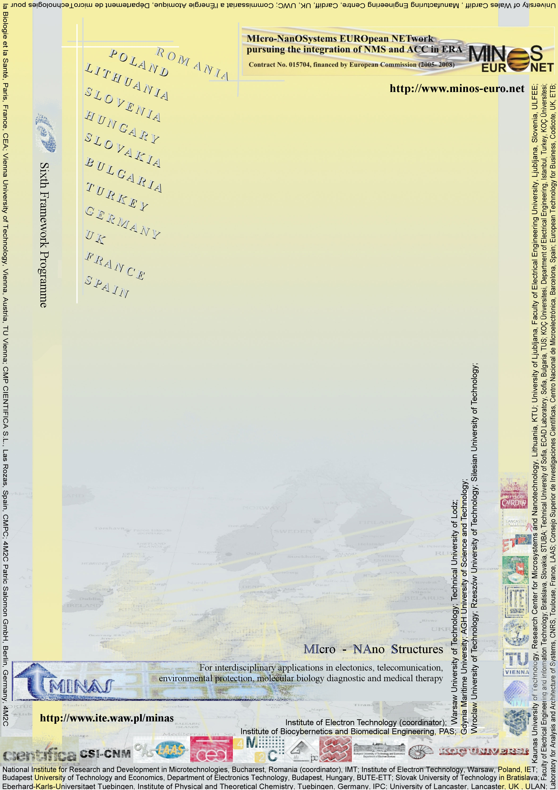

WARSAW Info Day and Brokerage Event
10-11.05.2006

Micro – and Nano – System networking activities towards FP7

Organizer: Institute of Electron Technology, Warsaw, Poland

Agenda:

May 10th

11.00. – Opening

11.05 –17.15 Plenary session: FP6 experiences and conclusions towards building FP7 consortia

11.05 “ENIAC - European's vision and practices for micro/nanoelectronics”. G.Q. (Kouchi) Zhang
11.45 “RF and and Millimeter Wave Micro and Nanosystems”. Robert Plana
12.15 “MST/MNT technologies for the agrofood industry”. Peter Ivanov, Neus Sabaté Vizcarra
12.45 “Advanced, medical application of microsystem technology”, Piotr Grabiec
13.15 "Roadmapping of multi-material micro manufacture technologies and its implications for future European research." Chris Matthews

13.45-14.45 Lunch

14.45 “MINOS - EURONET European Network pursuing the integration of NMS and ACC in ERA in the area of Micro- and Nanosystems”, Dan Dascalu
15.00 “Bio-mimetic approaches for gas sensing: MST platforms for Artificial Olfaction”.
Nikos Papamichail
15.30 “Centre of Microsystems Design and Technology – „COMBAT“ ,Jerzy Weremczuk
  - “MEMS for automotive industry ” Petr Louda
  - “IC and MST design and biosensors R&D activities in Slovak University
of Technology”, Viera Stopjakova, Julius Cirak
  - “Micro-nano Technology Research Activities at the Technical University
of Sofia , Anna Andonova
16.20 “RC for Microsystems and Nanotechnology, Valentinas Snitka
16.35 “Microdialysis based analytical system as a lab-on-chip type device
Dorota G. Pijanowska, Władysław Torbicz

16.50-17.10 Coffee break

17.10-19.00 Networking brokerage session

20.00- Conference dinner – “Kamienne Schodki” Restaurant

May 11th

9.00-14.00 Visits in Laboratories and further talks

